**ST. XAVIER’S COLLEGE**

**(Affiliated to Tribhuvan University)**

**Maitighar, Kathmandu**



**COMPUTER GRAPHICS**

**LAB ASSIGNMENT#6**

**Submitted by:**

Shreesha Pokharel

013BSCCSIT038

**Submitted to:**

|  |  |
| --- | --- |
| **Er. Anil K. Sah** |  |

Lecturer

Department of Computer Science

Date of submission: 25th August, 2015

**Statement: Implement midpoint ellipse algorithm.**

**Algorithm:**

Step 1: input center (xc,yc) and rx and ry for the ellipse and obtain the first point as (x0,y0)=(0, ry)

Step 2: calculate initial decision parameter value in region 1 as

P10=

Step 3: at each xk­ position, in region1, starting at k=0, compute

xk+1=xk+1

if p1k=p1k+2xk+1+

yk+1=yk+1

otherwise next point to plot is

yk+1=yk-1

P1k+1=P1k+xk+1+-2yk+1 with xk+1=xk+1 and yk+1=yk-1

Step 4: calculate the initial value of decision parameter at region 2 using last calculated point say (x0,y0) in region 1 as

P20=

Step 5: at each yk position in region 2 starting at k=0, perform computation

yk+1=y-1

if P2k>0, then

xk+1=xk

P2k+1=P2k-

Otherwise

xk+1=xk+1

P2k+1=P2k+2 where xk+1=xk+1 and yk+1=yk+1

Step 6: determine the symmetry points in other three quadrants.

Step 7: move each calculated point (xk,yk) on to the centered (xc,yc) ellipse path as

xk=xk+xc

yk=yk+yc

Step 8: repeat the process for region 1 until and region 2 until (xk,yk)=(rx,0).

**Source code:**

//---------------------------------------------------------------------------

#include <vcl\vcl.h>

#pragma hdrstop

#include "Unit1.h"

//---------------------------------------------------------------------------

#pragma resource "*.dfm"

TForm1 *Form1;

int xc,yc,rx,ry,x0,y0,pk;

//---------------------------------------------------------------------------

__fastcall TForm1::TForm1(TComponent* Owner)

: TForm(Owner)

{

}

//---------------------------------------------------------------------------

void __fastcall TForm1::Button1Click(TObject *Sender)

{

xc=StrToInt(Edit1->Text);

yc=StrToInt(Edit2->Text);

rx=StrToInt(Edit3->Text);

ry=StrToInt(Edit4->Text);

x0=0;

y0=ry;

pk=(ry*ry)-(rx*rx*ry)+((rx*rx)/4);

while((2*x0*ry*ry)<(2*y0*rx*rx))

{

Image1->Canvas->Pixels[xc+x0][yc-y0]=RGB(10,55,250);

Image1->Canvas->Pixels[xc-x0][yc+y0]=RGB(255,0,0);

Image1->Canvas->Pixels[xc+x0][yc+y0]=RGB(0,255,0);

Image1->Canvas->Pixels[xc-x0][yc-y0]=RGB(0,0,255);

if(pk<0)

{

x0=x0+1;

pk=pk+(2*ry*ry*x0)+(ry*ry);

}

else

{

x0=x0+1;

y0=y0-1;

pk=pk+(2*ry*ry*x0+ry*ry)-(2*rx*rx*y0);

}

}

pk=((float)x0+0.5)*((float)x0+0.5)*ry*ry+(y0-1)*(y0-1)*rx*rx-rx*rx*ry*ry;

while(y0>=0)

{

Image1->Canvas->Pixels[xc+x0][yc-y0]=RGB(10,55,250);

Image1->Canvas->Pixels[xc-x0][yc+y0]=RGB(255,0,0);

Image1->Canvas->Pixels[xc+x0][yc+y0]=RGB(0,255,0);

Image1->Canvas->Pixels[xc-x0][yc-y0]=RGB(0,0,255);

if(pk>0)

{

y0=y0-1;

pk=pk-(2*rx*rx*y0)+(rx*rx);

}

else

{

y0=y0-1;

x0=x0+1;

pk=pk+(2*ry*ry*x0)-(2*rx*rx*y0)-(rx*rx);

}

}

}

//---------------------------------------------------------------

**Input:**

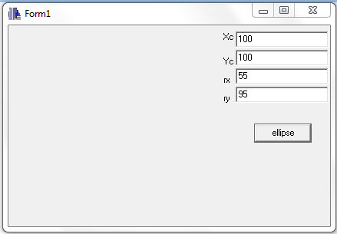

**Output:**

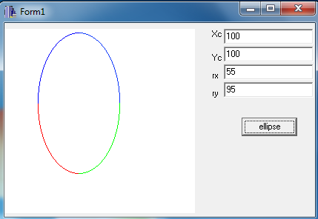

**Conclusion:**

Therefore, the midpoint ellipse algorithm was implemented as shown.

**References:**

[1] D. Hearn and M. Baker, Computer Graphics, second edition.